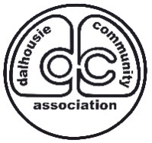
Event Information:
Date: May 29th & 30th *You can register for one day if you wish below
Time: 10am-3pm *you can stay open earlier/later, but this will be the time advertised!
Location: A Dalhousie Community Centre garage/yard
Cost: $10 (same price if you are registering for one day or two)
$10 Optional CASH ONLY Deposit –if you would like to borrow a DCA Garage Sale Sign *must not be tampered with and
Requirements: Must be located at a Dalhousie resident’s home
Is a DCA Membership Required?: No
What Is Provided With The Cost of Registration?: The DCA does a vast amount of marketing within and around the community, as well as on social media and our website. We provide the public with a map of all garage sales online and in-person.

Registration Information:
Name: ________________________________
Phone Number:__________________________
Email Address:___________________________
Address of Garage Sale:__________________________________
Date(s) of Garage Sale (Circle Which Apply): Sat. May 29, Sun. May 30
Would you like a Garage Sale Sign (cash deposit required)? ______
List of any major items you are selling (optional):
- ____________________________
- ____________________________
- ____________________________
Office Use Only
Payment Information:
Date of Payment/Registration:______________
Type of Payment:______________
Staff Receiving Payment:_________________

